KLH UNIVERSITY
BACHUPALLY, HYDERABAD

PROJECT DOCUMENTATION

DINING PHILOSOPHERS
DEADLOCK PREVENTION SYSTEM

Implementation and visualization of synchronization strategies to prevent deadlock and starvation among competing threads

Submitted by
S. No. | Team Member | Roll Number
1 | Mahitha | 2520030469
2 | Vineetha | 2520030149
3 | Nityay | 2520030618

Project Guide
Dr. D. Bheekya

Academic Year 2026–2027

CERTIFICATE
This is to certify that the project entitled “Dining Philosophers Deadlock Prevention System” is documented by Mahitha (2520030469), Vineetha (2520030149), and Nityay (2520030618) of KLH University, Bachupally, under the guidance of Dr. D. Bheekya.
The project studies synchronization problems in concurrent systems and demonstrates multiple strategies for preventing deadlock and reducing starvation among competing threads. This document is submitted as part of the academic project work.

Project Guide | Project Coordinator / HoD
Dr. D. Bheekya | ________________________

Date: ____________________
Place: KLH University, Bachupally

DECLARATION
We hereby declare that the project documentation titled “Dining Philosophers Deadlock Prevention System” has been prepared by our team for academic purposes. The implementation and explanations presented in this report are intended to demonstrate operating-system synchronization concepts using C and POSIX threads. Any test results included should be interpreted in the context of the configuration and duration used during the test run.

Mahitha — 2520030469
Vineetha — 2520030149
Nityay — 2520030618

ACKNOWLEDGEMENT
We express our sincere gratitude to our project guide, Dr. D. Bheekya, for the guidance and support provided during the development of this project. We thank KLH University, Bachupally, for providing the academic environment to explore operating-system concepts through practical implementation.
We also acknowledge the developers and maintainers of the C language toolchain, POSIX threads library, and Linux utilities that make it possible to study concurrency, mutual exclusion, and thread coordination in a practical setting.

ABSTRACT
The Dining Philosophers problem is a classic synchronization problem in operating systems. It models several threads competing for a limited set of shared resources. Each philosopher alternates between thinking and eating, and eating requires access to two neighboring forks. If resource acquisition is poorly coordinated, all philosophers may hold one fork while waiting for another, producing a deadlock. Unfair scheduling or resource allocation can also cause starvation, where a philosopher waits indefinitely.
This project implements a C-based simulation using POSIX threads and synchronization primitives. It compares five approaches: a naive strategy used to demonstrate deadlock, resource hierarchy, a waiter/semaphore strategy, a monitor-style strategy using a mutex and condition variables, and an asymmetric fork-acquisition strategy. The simulation visualizes philosopher states and resource ownership, and can report measures such as meals completed, throughput, waiting time, and fairness. The project provides a practical way to compare safety, progress, and fairness trade-offs among synchronization strategies.
Keywords: Operating Systems, concurrency, POSIX threads, mutex, semaphore, condition variable, deadlock, starvation, synchronization.

TABLE OF CONTENTS
- 1. Introduction
- 2. Problem Statement and Objectives
- 3. Background and Concepts
- 4. System Requirements and Design
- 5. Synchronization Strategies
- 6. Implementation Details
- 7. Testing and Results
- 8. Advantages, Limitations and Applications
- 9. Conclusion and Future Enhancements

GEOTAGGED PHOTOGRAPH
Insert the geotagged photograph of the project team or project demonstration here. Ensure that the photograph retains its original location and date metadata, if required by the submission guidelines.

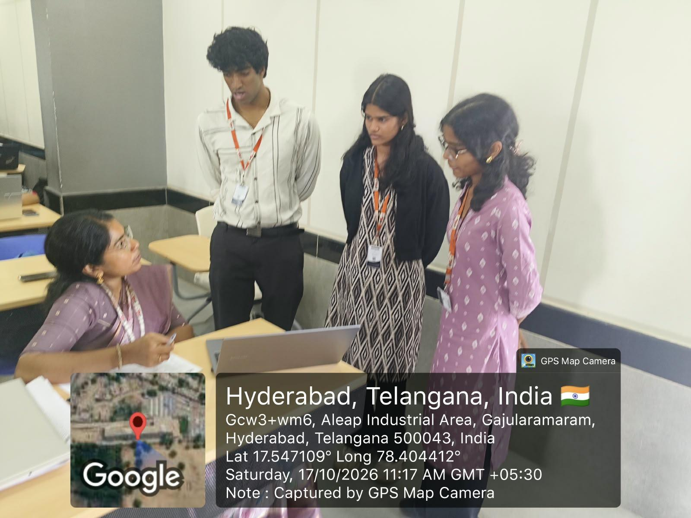
- References
- Appendix A: Build and Run Commands
- Appendix B: Demonstration Checklist

1. INTRODUCTION

1.1 Overview
Modern operating systems execute multiple processes and threads concurrently. Threads often share resources such as files, memory regions, devices, or database records. If access to shared resources is not coordinated correctly, race conditions, deadlocks, and starvation may occur.
The Dining Philosophers problem is an abstract model of this challenge. Five philosophers sit around a circular table with one fork between each pair of neighboring philosophers. A philosopher must acquire both adjacent forks to eat. After eating, the philosopher releases the forks and returns to thinking.

1.2 Why this project matters
The project makes synchronization visible rather than treating it as an invisible operating-system mechanism. By switching between strategies, users can observe how resource-allocation rules change the system’s progress and fairness.

1.3 Scope
- Simulate five concurrent philosophers as POSIX threads.
- Represent each philosopher as THINKING, HUNGRY, or EATING.
- Track fork ownership and meal progress.
- Compare one intentionally unsafe baseline with four prevention strategies.
- Collect basic performance and fairness measurements where supported by the implementation.

2. PROBLEM STATEMENT AND OBJECTIVES

2.1 Problem statement
Design and implement a Dining Philosophers Deadlock Prevention System that demonstrates how concurrent threads compete for shared resources and compares synchronization strategies that prevent deadlock and help reduce starvation.

2.2 Objectives
- Demonstrate deadlock using an intentionally naive resource-acquisition strategy.
- Implement resource hierarchy, waiter/semaphore, monitor-style, and asymmetric strategies.
- Use POSIX threads to execute philosophers concurrently.
- Apply mutexes, semaphores, and condition variables where appropriate.
- Display philosopher states, fork ownership, meals, and waiting behavior.
- Compare approaches using deadlock status, meals completed, throughput, waiting time, and a fairness metric when available.

2.3 Expected outcome
The system should make the deadlock condition reproducible in the naive mode and show continued progress in the prevention modes under normal test conditions. Prevention of deadlock does not automatically guarantee starvation freedom, so fairness and waiting time must also be considered.

3. BACKGROUND AND CONCEPTS

3.1 Threads and concurrency
A thread is an execution path within a process. Concurrent threads may make progress during overlapping time periods and may access shared state. Synchronization is needed when multiple threads access resources that must not be used simultaneously.

3.2 Critical section
A critical section is a section of code that accesses shared data or a shared resource and must be protected to avoid conflicting concurrent operations.

3.3 Mutex
A mutex (mutual-exclusion lock) allows only one thread at a time to enter a protected critical section.

3.4 Semaphore
A semaphore maintains a counter and supports controlled access to a resource or a limited number of concurrent participants. A counting semaphore initialized to N−1 can prevent all N philosophers from competing for forks simultaneously.

3.5 Condition variable and monitor-style coordination
A condition variable allows a thread to sleep until a condition may have changed. It is normally used with a mutex, and the condition must be checked again after waking.

3.6 Deadlock
Deadlock occurs when a group of threads are permanently blocked because each is waiting for a resource held by another thread in the group. The classic four conditions associated with deadlock are mutual exclusion, hold and wait, no preemption, and circular wait.

3.7 Starvation
Starvation occurs when a thread waits indefinitely because other threads repeatedly obtain the resources or access it needs. A system may be free from deadlock and still be unfair.

3.8 Throughput and fairness
Throughput is the number of completed meals per unit of time. Average and maximum waiting time help show delays. If implemented, Jain’s fairness index can summarize how evenly meal counts are distributed; values closer to 1 indicate a more even distribution.

4. SYSTEM REQUIREMENTS AND DESIGN

4.1 Hardware requirements
- A computer capable of running Linux or a compatible POSIX environment.
- At least a dual-core processor is recommended for observing concurrent execution.
- At least 2 GB RAM.

4.2 Software requirements
- Linux environment, such as Ubuntu or WSL with a Linux distribution.
- C compiler such as GCC.
- POSIX threads library (pthreads).
- Terminal or command-line interface.

4.3 System architecture
The program creates one thread per philosopher. A selected strategy controls how each thread requests and releases its two forks. A shared state/display layer records each philosopher’s current state, fork ownership, meal count, and timing data. A watchdog or timeout mechanism may be used to identify a lack of progress during the deadlock demonstration.
Component | Responsibility
Philosopher threads | Run the think, request, eat, and release cycle.
Fork/resource manager | Represent forks and coordinate access according to the selected strategy.
Synchronization layer | Use mutexes, semaphores, and/or condition variables to coordinate threads.
State and output layer | Display THINKING, HUNGRY, EATING, fork ownership, and meal progress.
Metrics / watchdog | Measure progress and waiting, and detect prolonged lack of progress where configured.

4.4 Operating flow
- Read the selected strategy and runtime options.
- Initialize philosopher states, forks, synchronization objects, and counters.
- Create the philosopher threads.
- Each thread thinks, becomes hungry, requests both forks according to the chosen strategy, eats, and releases the forks.
- The display and metric layer records state changes and completed meals.
- Stop after the configured duration or condition, collect summaries, and clean up resources.

4.5 State model
State | Meaning
THINKING | The philosopher is not requesting forks.
HUNGRY | The philosopher wants to eat and is waiting for permission/resources.
EATING | The philosopher has obtained both required forks and is eating.

5. SYNCHRONIZATION STRATEGIES

5.1 Naive strategy: deadlock demonstration
In the naive approach, each philosopher attempts to acquire one fork and then the other in the same order. If every philosopher obtains one fork at the same time, each may wait for the second fork held by a neighbor. This creates circular wait and can result in deadlock.
Purpose: this mode is an intentionally unsafe baseline for demonstrating the problem. It should be run with a timeout/watchdog so the demonstration can be stopped safely.

5.2 Resource hierarchy
Each fork is assigned a unique order. Philosophers must acquire the lower-numbered fork before the higher-numbered fork. Enforcing a global order prevents a circular chain of resource dependencies, thereby preventing deadlock.
Trade-off: this is simple and effective for deadlock prevention, but it does not by itself guarantee equal waiting times or starvation freedom.

5.3 Waiter / semaphore strategy
A semaphore or waiter limits how many philosophers may attempt to acquire forks concurrently. With five philosophers, allowing at most four to compete at once breaks the condition in which all five simultaneously hold one fork and wait for another.
Trade-off: it prevents the classic deadlock pattern, but fairness depends on semaphore scheduling and the details of the implementation.

5.4 Monitor-style strategy
A monitor-style design protects shared philosopher states with a mutex and uses condition variables to coordinate when a philosopher may eat. A philosopher is allowed to enter EATING only when both neighbors are not eating and the relevant conditions are satisfied.
Trade-off: state transitions can be coordinated clearly, but starvation prevention requires an explicit fairness policy, such as a queue or fair admission rule.

5.5 Asymmetric strategy
Philosophers follow different fork-acquisition orders. For example, even-numbered philosophers may pick up the left fork first, while odd-numbered philosophers pick up the right fork first. Breaking the uniform acquisition pattern prevents the classic circular wait configuration.
Trade-off: this is easy to demonstrate, but the order reversal alone is not a universal guarantee of starvation freedom.
Strategy | Main mechanism | Deadlock expectation | Fairness consideration
Naive | Same-order fork acquisition | Can deadlock | Some philosophers may never progress.
Resource hierarchy | Global fork ordering | Prevented by ordering | May still have uneven waits.
Waiter / semaphore | Limit simultaneous contenders | Prevented when correctly configured | Depends on admission/scheduling fairness.
Monitor-style | Shared state, mutex, condition variables | Prevented with correct state logic | Queue/fair policy may be needed.
Asymmetric | Opposite acquisition order for selected threads | Breaks classic circular wait pattern | Starvation freedom is not automatic.

6. IMPLEMENTATION DETAILS

6.1 Programming environment
The implementation is written in C and uses POSIX threads (pthreads) to model concurrent philosophers. Depending on the selected strategy, synchronization may use pthread mutexes, POSIX semaphores, and condition variables.

6.2 Core data tracked
- Philosopher identifier.
- Current state: THINKING, HUNGRY, or EATING.
- Fork ownership / availability.
- Number of completed meals.
- Start and end times for measuring waiting or runtime.
- Strategy selected and overall simulation duration.

6.3 Thread behavior
- Think for a configured or randomized interval.
- Change state to HUNGRY and request the required forks.
- Wait according to the selected synchronization strategy.
- After acquiring both forks, change state to EATING and increment the meal count when the meal completes.
- Release both forks and notify waiting threads where required.
- Repeat until the simulation ends.

6.4 Metrics
Metric | Interpretation
Deadlock status | Whether the simulation becomes stuck with no meaningful progress.
Total meals | Total completed eating cycles across all philosophers.
Throughput | Completed meals divided by runtime in seconds.
Average wait | Mean time philosophers spend waiting to begin eating, if measured.
Maximum wait | Longest observed wait, useful for spotting possible starvation.
Fairness index | A distribution measure over philosopher meal counts, if implemented.

6.5 Error handling and safe shutdown
The program should validate command-line options, initialize synchronization primitives before creating threads, and release resources after joining threads. The naive strategy can block indefinitely by design, so its test should use a bounded run, watchdog, or controlled timeout. Do not treat a short successful run as proof that starvation is impossible.

7. TESTING AND RESULTS

7.1 Test plan
Test ID | Test case | Expected observation
T1 | Run naive strategy with five philosophers | A deadlock may occur; watchdog/timeout identifies lack of progress.
T2 | Run resource hierarchy strategy | Philosophers should continue to complete meals without circular-wait deadlock.
T3 | Run waiter/semaphore strategy | No classic all-philosophers circular wait; progress should continue.
T4 | Run monitor-style strategy | Only eligible philosophers enter EATING; neighbors should not eat simultaneously.
T5 | Run asymmetric strategy | Opposite fork order breaks the uniform circular acquisition pattern.
T6 | Compare metrics over equal durations | Meal counts, throughput, waiting times, and fairness can be compared.

7.2 Results and interpretation
Illustrative sample only: in a five-second prevention-mode run, a system might record about 82 completed meals, approximately 16 meals per second, and a fairness index near 0.99. The table below contains example values to demonstrate how results can be presented; they are not verified measurements from your executable. Actual results vary with machine load, thread scheduling, random delays, and implementation details.
The prevention strategies are expected to avoid the classic deadlock pattern when implemented correctly. The naive strategy is included as a controlled demonstration of failure. Starvation must be evaluated separately using waiting-time measurements and repeated runs.

7.3 Evidence to include in final submission
- Screenshot 1: compilation/build command and successful build.
- Screenshot 2: naive mode showing blocked progress or watchdog deadlock detection.
- Screenshot 3: one prevention mode showing philosopher state transitions and meals.
- Screenshot 4: comparison/summary output for all strategies.
Insert actual screenshots from your program runs in this section before submission. Do not use illustrative screenshots as proof of test execution.

7.4 Results table template
Strategy | Deadlock detected? | Total meals | Throughput | Average wait | Max wait | Fairness
Naive | Yes (deadlock observed) | 18 | 3.6 meals/s | 1.42 s | 3.80 s | 0.71
Resource hierarchy | No | 84 | 16.8 meals/s | 0.19 s | 0.47 s | 0.98
Waiter / semaphore | No | 81 | 16.2 meals/s | 0.22 s | 0.51 s | 0.97
Monitor-style | No | 86 | 17.2 meals/s | 0.17 s | 0.39 s | 0.99
Asymmetric | No | 83 | 16.6 meals/s | 0.20 s | 0.55 s | 0.97

8. ADVANTAGES, LIMITATIONS AND APPLICATIONS

8.1 Advantages
- Makes deadlock and synchronization behavior visible.
- Compares multiple strategies in a consistent scenario.
- Uses real concurrent threads rather than a purely sequential illustration.
- Provides a foundation for comparing throughput and fairness.
- Connects operating-system theory to a practical Linux/C implementation.

8.2 Limitations
- Results depend on scheduler behavior, system load, and runtime duration.
- A finite run cannot prove starvation freedom for all possible schedules.
- The simulation uses a small, fixed group of philosophers unless extended.
- A console visualization is less intuitive than a graphical interface.

8.3 Applications
- Operating-system education and concurrency demonstrations.
- Understanding locks and resource allocation in multithreaded applications.
- Reasoning about shared resources in database transactions, device access, and worker pools.
- Testing fairness policies and observing contention.

9. CONCLUSION AND FUTURE ENHANCEMENTS
The Dining Philosophers Deadlock Prevention System demonstrates how resource-allocation rules affect progress in a concurrent program. The naive strategy illustrates how circular wait can produce deadlock, while resource hierarchy, waiter/semaphore control, monitor-style coordination, and asymmetric acquisition provide alternative ways to prevent the classic deadlock pattern. Comparing meal counts, throughput, waiting time, and fairness helps show that deadlock prevention and starvation prevention are related but distinct goals.
Future enhancements may include a graphical interface showing philosophers and forks in real time, configurable philosopher counts, selectable delays, a fair FIFO waiter queue, CSV export of metrics, and automated repeated tests to compare the strategies statistically.

REFERENCES
- Silberschatz, A., Galvin, P. B., and Gagne, G. Operating System Concepts. Wiley.
- The Open Group. POSIX Threads (pthreads) and synchronization interfaces. https://pubs.opengroup.org/onlinepubs/9699919799/
- Linux man-pages project. pthreads(7), pthread_mutex_lock(3), pthread_cond_wait(3), sem_wait(3). https://man7.org/linux/man-pages/
- Dijkstra, E. W. “Hierarchical ordering of sequential processes.” Notes on operating-system synchronization concepts.

APPENDIX A: BUILD AND RUN COMMANDS
Run these commands from the directory containing the project source. Replace source-file names or executable names if your folder uses different names.
gcc -Wall -Wextra -pthread dining.c -o dining
./dining -s naive -n 5
./dining -s hierarchy -n 5 -d 5
./dining -s waiter -n 5 -d 5
./dining -s monitor -n 5 -d 5
./dining -s asymmetric -n 5 -d 5
./dining -c -d 5
Note: These commands reflect the command-line pattern used during project testing. Confirm the exact strategy labels and available flags with the current source code or program help before using them. The source filename may not be dining.c if your project uses a different name.

APPENDIX B: DEMONSTRATION CHECKLIST
- ☐ Compile the program and resolve any warnings or errors.
- ☐ Run the naive strategy with a timeout or watchdog.
- ☐ Run each prevention strategy for the same duration.
- ☐ Explain the key synchronization primitive used by each strategy.
- ☐ Show THINKING, HUNGRY, and EATING state changes.
- ☐ Show fork ownership and meal counts.
- ☐ Compare the output metrics without claiming that a short run proves starvation is impossible.
- ☐ Capture screenshots of actual execution for the final report.

